|  |  |
| --- | --- |
|  |  |
| *INFORMATION AND COMMUNICATION TECHNOLOGY (ICT):* |  |
|  |  |
|  | 16 February,2024ICT |
|  | 1. Muhammad Haseeb 2. SharjeelRole no:240040 Roll no: 240016 |

**Planning Your Portfolio Website**

This is a great start to planning my portfolio website Here's a breakdown of the tasks that are involved in planning phase

**Task 1: Define Your Purpose and Audience**

**Purpose:**

* Digitalizing the clothing stores: My mainly idea focuses on the clothing brands that we can target so that we can solve their problem and make their business on the large scale.

**Target Audience:**

* We focuses on the men’s women and child clothing but we digitalize it because some people wants to buy clothing online to save their time and also they don’t want to go outside for shopping so they prefer online shopping

**Task 2: Sketch Your Website Layout on Figma**

**Figma:**

Figma is a great tool for creating wireframes and prototypes to visualize your website's structure and functionality. Here are some points to consider for my Figma designs:

**Layout:**

* **Sections:** Consider including the following sections:

**Home:** A captivating introduction with your name, a brief bio, and a call to action (e.g., contact you).

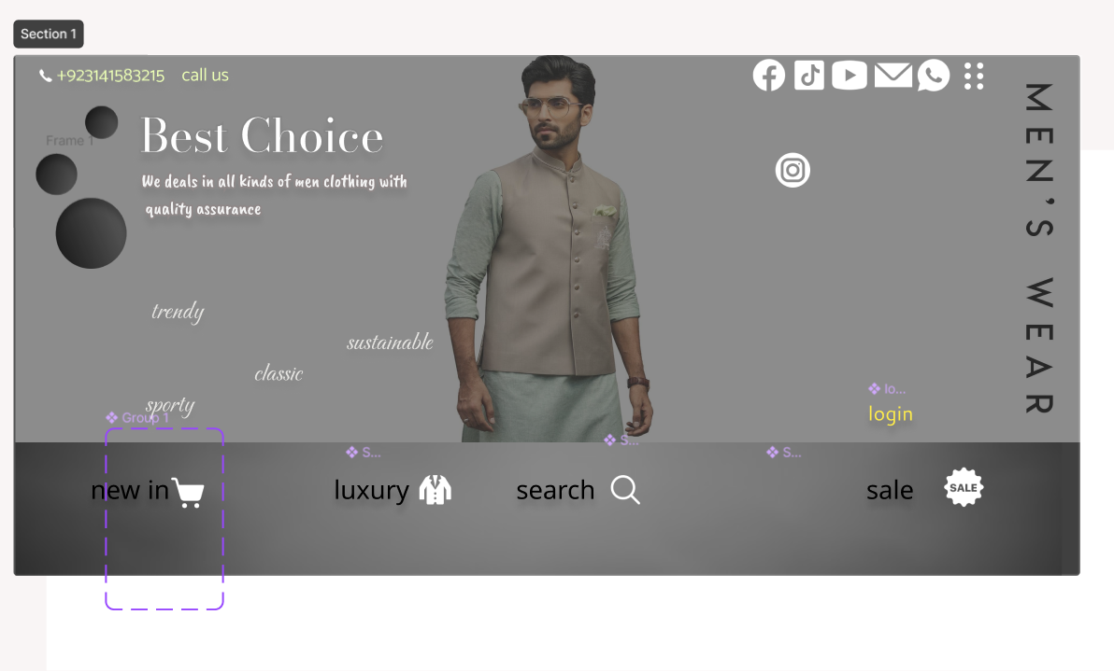

* + **About Me:** Telling story, experiences, and skills relevant to your audience.

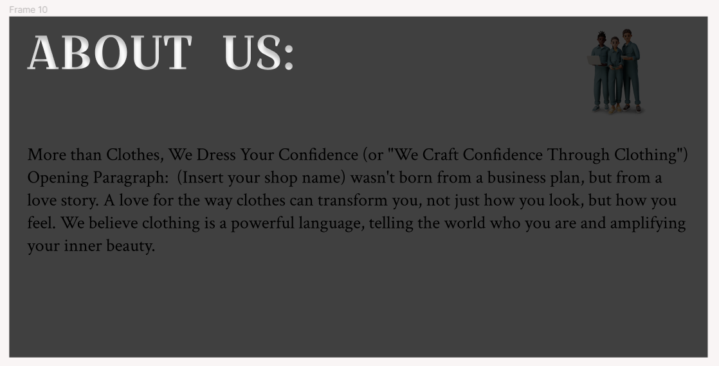

* + Projects: Showcase your strongest projects with clear visuals, descriptions, and links (if applicable). 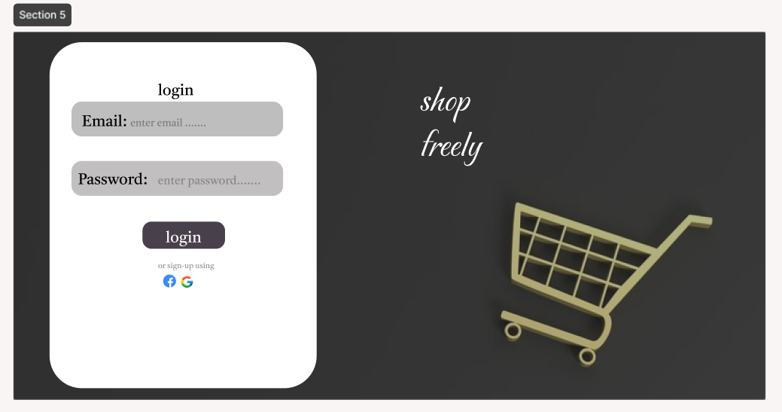 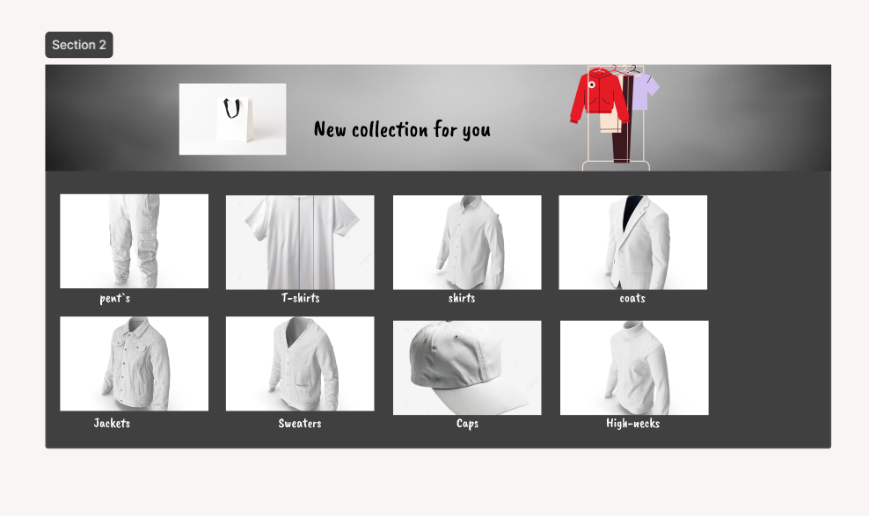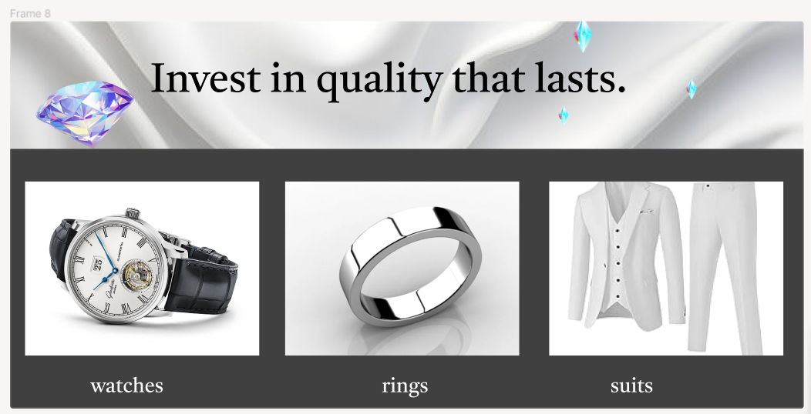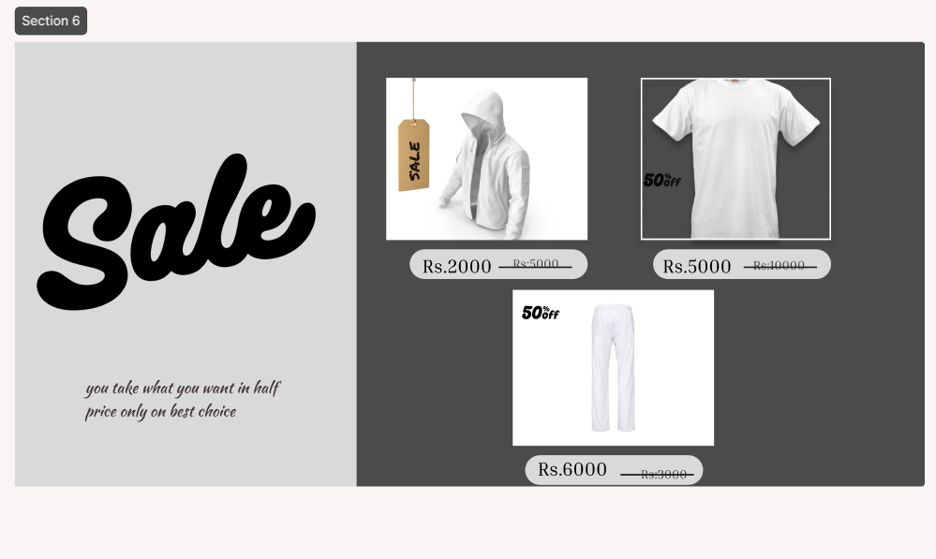
  + Skills: Highlight your technical and soft skills using icons, keywords, or progress bars.
  + Contact: Provide clear ways for people to contact us 
* **Navigation:** my website is easy to navigate. Use a clear menu system or breadcrumb navigation.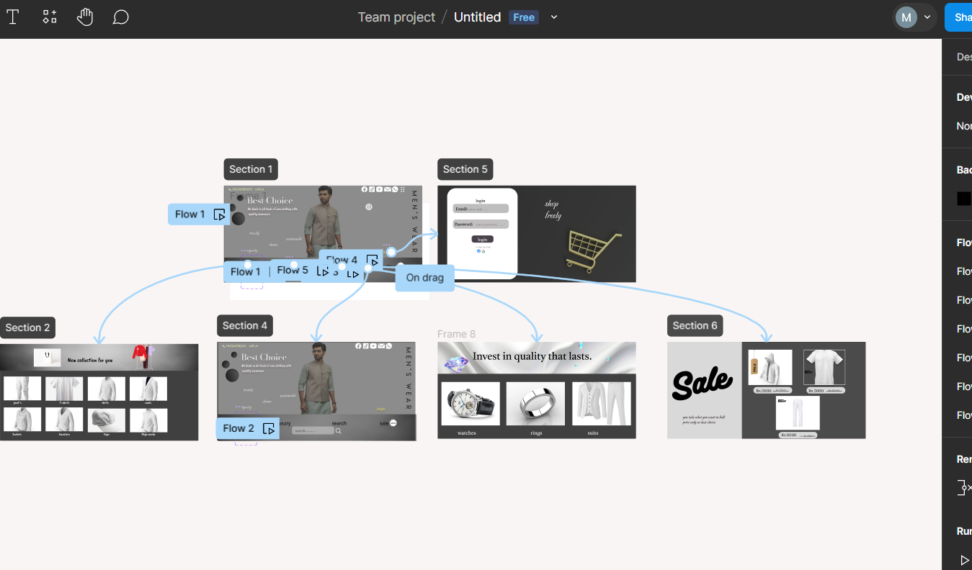

**Design:**

* Color Scheme: this website contains the contrasted colors of ash white and gray color
* Aesthetics: we mainly focus on user friendly and visually appealing website that attract user and don’t really irritate them.

**Additional Tips:**

* Mobile Responsiveness: my website looks good and functions flawlessly on all screen sizes (desktop, mobile, tablet).
* Content: Focus on high-quality content that is engaging and informative.
* Call to Action (CTA): Clearly guide visitors on what I want them to do after browsing your portfolio (e.g., contact us, view a project, etc.)